FEAR – Physics_01 tutorial

Introduction

Getting Started

Most of the topics that you’ll find in this series of tutorials have their basis in the default WorldEdit manual which you can find in WorldEdit itself by clicking the Help section in WorldEdit and then clicking “Topics.”

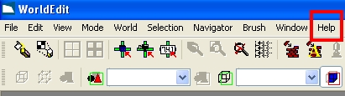

Once you’ve clicked Topics, you’ll want to expand the WorldEdit section of the help file and then browse to Physics. The four subsections of the Physics topic will provide you with a solid fundamental understanding of how to create objects that have physical properties. It is essential reading for any Level Designer.

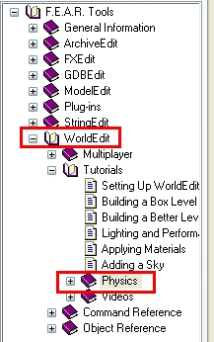

Why Physics?

When you’ve finished reading the tutorials mentioned above, you’ll have seen a few good examples of objects that were made physical in the original F.E.A.R. game (a coffee mug, a chair, etc.) You’ll generally want to make any decorative items you place in the world physics-enabled because it adds to the overall immersion of the level as well as looking really cool when you throw grenades in the general vicinity of the objects.

Useful Examples

Physics objects can also be used to create dynamic scripted events, such as the ones you’ll find in Hospital_01 in XP 1. You’ll see the Assassins climb up through seemingly solid ceiling tiles and knock them down. They collide and bounce around realistically, helping to lend an ominous feel to the level. Also, many of the breakable crate prefabs have extensive physical properties to really add a nice effect when they break open.

If you ever want to open up an existing prefab to look at its physics properties, simply select the prefab in the world or in the Prefabs menu, and then click Open

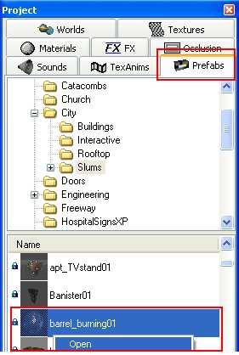

Demonstration World (physics_01)

Exploring the Demonstration World

I’ve created a demonstration world with some various physics objects that you might find useful to imitate when creating your own world. The Physics_01 world was made with the idea in mind that as of 09/20/06, we believe that FEAR XP 2 will call for a lot more destruction in the environments and I certainly think that the old “rubble falling from the ceiling and scaring you to death in a claustrophobic tunnel™” trick is definitely appropriate considering that.

Creating The Falling Rocks

When you open up the world, look in the node 006-AI-Game Play. This node contains all of the entities and brushes that make the rock fall event possible. It is essentially just a slight variation of the very first physics tutorial that you’ll find in the Physics section of the help file mentioned above.

To create the broken ceiling shapes similar to the ones in the level, simply use the clip tool (Spacebar) to shape some cube brushes to make them look “chipped.” Then you make the brush you’ve shaped to your satisfaction and make it the child of a WorldModel entity. You should have a good idea how to tweak the physical properties of the object from the information you read in the manual.

If something isn’t clear to you about how the scene works, I’ve commented out a good deal of the scripting in the main trigger (A01-EventTrigger) that sets up the event. This should help to give you a better idea about how a similar event would need to be set up (changing solid walls to destroyed-looking ones, etc.)

